_____________________________________________________________________________

TECHNICAL DESIGN DOCUMENT

Omni Channel Support & Case Management System
_____________________________________________________________________________
VERSION 1

Contents
1. Project Overview 3
2. User Requirements (BRD) 3
3. Use case Diagrams 10
4. Technical Specifications 16
5. Proposed Steercom 17
6. Projected Effort, Costs and Timelines 18
7. Business Case 19
8. Key Notes 20
9. Distribution List 21

Project Overview

Executive Summary | URS Reference | URS Submitter | Objectives | Out of Scope
The current case management solution (Ameyo Tracking System) is unable to efficiently and effectively manage customers incidences as the system has reached the end of its life and is no longer being supported by the enabler, Sugar CRM. Not only is the system obsolete, it is inefficient and cannot meet all key business needs (current and emergent such as Omni channel support, SLA management, workflow, etc. | Omni Channel Support & Case Management Solution | Evans Miyanda | To implement an omni channel support and case management system that will meet the current and emergent business needs such as Omni channel support, SLA management, workflow management, staff productivity management, analytics and dashboard, customer 360 & case history, etc. | Product configuration is out of scope of this project.

User Requirements (BRD)

Requirement | Name | User Story | Requirement Description | Problem Statement
Requesters Use cases
 | Log In | As Service & Client  solutions, we want to maintain the current login process | Customers currently log in with their user name and password and this process should remain as is. | The current logging-in process should not change
 | Registration | As Service & Client  solutions, we want to maintain the current registration process | Admin should be able to create users on the platform as is the current process | The current registration process should not change
 | Omni Channel Support & Case  Management Solution | As Service & Client  Solutions, we want to have a new Omni Channel setup & Case Management System that can meet current and emergent business needs | To meet the current and emergent business needs, the business is looking for an Omni Channel Support and Case Management solution that can meet current and emergent business needs such as Omni Channel support, SLA Management, Workflow Management, staff productivity management, Analytics and Dashboards, customer 360 & case history etc. | The current Case Management Solutions (Ameyo Ticketing System) is unable to efficiently and effectively manage customer incidences as the system has reached the end of life its and is no longer being supported by the enabler, SugarCRM. Not only is the system obsolete, it is inefficient and cannot meet all key business needs (current and emergent such as Omni Channel support, SLA management, workflow  etc.)
 | Omni Channel | As Service & Client  Solutions, we want to have  an Omni Channel setup as  opposed to the current Multi  Channel | An Omni-channel which includes Voice, SMS, Email, Chat on a web portal (Like a Chatbot), WhatsApp, FB, Twitter and Web Portal (Through form submission) | We currently have limited Multichannel
 | User access | As Service & Client  Solutions, we want the  system to be accessed by  both front and back office  users | The system should accessible to branches, Service & Client Solutions, operations, | Currently available
 | Web Interface | A service & Client  Solutions, we want the  system to be web-based | The system is to web-based accessed in Microsoft Edge, Google Chrome, Mozilla Firefox | Currently available
 | Case Login 1 | As Service & Client  Solutions, we all front line  staff to be creating cases | Call Centre agents, Service Assistants, APBs should have the ability to create and login cases for customers. | Currently available
 | Case Login 2 | As Service & Client  Solutions, we want staff to  be able to create cases  from digital channels | The ability to create cases from email, WhatsApp, Facebook, Twitter etc.  conversations. | Currently not available
 | Routing of Cases | As Service & Client  Solutions, we want to have  A system that will route cases  on a rule basis | Routing of cases to teams/groups based on the outcome and the workflow | Currently, routing of cases is not a rule based
 | Seamless Communication | As Service & Client  Solutions, we want to have a seamless communication  amongst different channels | Seamless communication among different channels | The system is not having a seamless plan for non-voice channels (Email & SMS)
 | Case Workflow | As Service & Client  Solutions, we want to have a Case Workflow on our system | The solution should have a case process workflow that is configurable according to case types and query types | Currently, we do not have a Case Workflow
 | Improved Analytics | As Service & Client  Solutions, we want to have improved analytics  a process that is not limitations | The analytics should be configurable according to business needs. | System analytics and reports are available but have limitations
 | SLA Management | As Service & Client  Solutions, we want to have an SLA management system | SLA Management should be configurable according to incident types. | Currently, we do, not have SLA Management
 | Consistent Notification | As Service & Client  Solutions, we want to have automated and consistent notifications are being sent to users via email | Automated, consistent and timely notifications in accordance with the rules and defined events in the system. | Notifications are currently not consistent
 | Customizable Dashboard | As Service & Client Solutions, we want to be  able to customize our dashboard | Customized dashboard for each business unit that shows the overall number of cases, number of cases per status type, cases assigned to each staff and their status and filters including time and date. | Currently, the dashboard is not customizable
 | Re-routing of cases | As DMO, we want each team to be able to reassign cases to other teams | Each team should be able to reassign cases to other teams | Currently available
 | Separate Dashboard | As Service & Client  Solutions, we want a  separate dashboard for different teams | Each team views its own dashboard in order to effectively monitor and manage tickets | Currently not available
 | Admin Page/Superuser | As Service & Client  Solutions, we want the Admin to be able to have an overall view of tickets pans bank | Admin should be able to see the Pan Bank view of all tickets in the system. i.e. view all queues and the status of their tickets, date and time filters. | Currently, Admin is not able to see  tickets pending for each agent
 | Routing of Contacts | As Service & Client  Solutions, we want to be  able to have a system that will route customer  interactions on a rule basis | Routing of contacts/conversations from Facebook, WhatsApp, Twitter, Email, etc. should be based on rules such as FIFO, priority etc. | Currently, the routing of contacts is not Rule-based
 | Measure of Cases | As Service & Client Solutions, we want the  system to measure cases  based on the time spent in a queue and overall lifespan | The measure of cases based on time spent in a queue and not lifespan | Currently, a measure of cases is based on time span
 | Prioritization and assignment  of contacts | As Service & Client  Solutions, we want to be  able to prioritize and  assign contacts | Prioritization and assignment of contacts conversations based on rules. | No System prioritization and assignment of contacts
 | Prioritization of Cases | As Service & Client  Solutions, we want to be  able to prioritize and  assigned cases | Prioritization and assignment of cases | No System prioritization of cases
 | A Change log | As Service & Client  Solutions, we want to ensure we have a change log so that we can have an Audit trail | A change log should be available for every case detailing all changes, times and dates of change and the user. | The change log should also be on the new the system as is the current system
 | Favourite Option | As Service & Client  Solutions, we want to ensure  we have a favourite option | We want a favourite or side panel that  will enable us to ping selective cases for  quick view and follow-ups. | Favourite option should also be on the  new system as is the current system
 | Attachments | As Service & Client  Solutions & CIB we want to all users to be able to attach and download documents (PDF, pictures,  etc.) to tickets | Provision to attach and download files  both at the front end and at the back end. | Currently, the system does not allow Agents  to link more than one statement to a  single case
 | Statement | As Service & Client  Solutions & CIB we want the system to be able to link more than one statement to a single case | One Case should accommodate more than one statement rather than opening multiple cases even if the queries are similar and for one person (Should be configurable) | Currently, the system does not allow Agents to link more than one statement to a single case
 | Email cases | As Transactional Banking, we would like to see cases sent through email captured by the system and logged as cases for tracking and  closure. | Cases sent through email are captured by the system and logged as cases for tracking and closure. | As Transactional Banking, customer queries come through email and it is difficult to gather Open, WIP and closure statistics through email. Benefit: improved allocation of tasks,  monitoring and reporting
 | Internet Banking | As Transactional Banking, we would like our customers to have the case management link on our Internet Banking platform in order to log queries from there | Customers to have the case management link on our Internet Banking platform in order to log queries from there | As Transactional Banking, customer  queries come through email and it is  difficult to gather Open, WIP and  closure statistics through email.  Benefit: improved TAT on issue logging  and resolution
 | Mobile Banking | As Service & Client Solutions, we want customers on the mobile app to be able to log queries directly into the  system | Customers should have the ability to log queries from the mobile app. | Mobile Banking Integration
 | Conversions for Email | As Service & Client  Solutions, we want to have  manual conversion of emails  to tickets | The team needs the ability to convert emails to tickets as and when needed. The user will have to determine whether a ticket is required or not. *note* available for customer service team only | We do not want to have automatic  conversions of emails.  The downside of having automatic  conversions is that all emails  including enquiries and non-relevant  emails get converted to tickets.
 | Conversions for Calls | As Service & Client  Solutions, we do not want to  have calls converted into  tickets | Calls should not be converted into calls | Having automatic conversions is that  all Calls including enquiries and non  relevant emails get converted to  tickets.
 | Ameyo Call Manager Integration | As Service & Client Solutions, we want the Omni Channel & Case Management Solution to integrate with current Call Centre Solution | Solution to be integrated with Ameyo Call  Manager to allow the agents and  supervisors to access the call manager and  case management solution in one window  with single login. | Currently available
 | Integration with existing  Banking application | As Client Solutions, we want the solution to be integrated with banking applications for customer information | The solution to be integrated with existing banking application/customer DB for the purpose of customer information and to allow staff to be creating cases under a customer profile | Currently unavailable
 | FCR Count | As Retail Credit & eChannel’s Support, we want the rule for FCR count to be restricted to working hours or cases not to be logged in after hours | The rule for FCR count to be restricted to working hours or cases not to be logged in after hours.  Notifications, TAT & SLA counters and escalations to be applicable during operational hours only. | Queries are all LMS system-related and LMS closes at 17hrs and is only available on non-working days upon request. This impacts Retail Credit FCR as they are unable to respond to queries after working hours.
 | Cases routed to queue with  days | As Retail Credit, we want cases that were wrongly routed to a queue to start at zero days. | If a case was wrongly routed to a queue and is being re-routed to another queue, the count should start at zero days. | Cases that are wrongly queued are currently not being counted from zero days
 | Re-opened Cases | As Retail Credit, we want cases not to be re-opened by customers checking their emails | Cases should not be re-opened by customers checking their emails if an email address was added in Ameyo. | Cases are currently being re-opened by customers checking their emails
 | Archived Data | As EChannels Support, we want to be able to access achieved data directly from the client machine, not through IT | Easy and direct access to archived records. | Currently available
 | Operational hours | As Client Solutions, we want to be able to define the operational hours for each business unit on the system | ability to define operational hours for each business unit or queue on the system. | Currently available
 | Operational restrictions on  cases | As Branches, we want the ability to restrict the  closure of cases by non-case owners | Non-case owners should not have the ability to close cases except for queue owner | Currently available
Reporting Use cases
 | Report generation | As Business Banking, we want the Report generation at month to clearly show tallying query and service requests | Report generation at month end clearly  tallying with query and service requests | The current report does not show tallying- query and service requests
 | Team Performance | As Service & Client  Solutions, we want the  reports to be showing team  performance | Summarized and detailed team/group reports  of the team’s performance | Currently available but missing some key details
 | Individual Staff Performance | As Service & Client  Solutions, we want to have  reports showing individual  staff performance | The reports should show information such  as:  1. number of cases  2. status summary  3. SLA adherence  4. average handling time  5. total handle time, etc. | Currently unavailable
 | User details & Case owners | As Service & Client Support,  we want detailed reports to  show user details and case  owners | The detailed reports should show:  1. login date & time  2. time assigned to support queue  3. case creator  4. case owner  5. TAT  6. A status  7. Case status  8. case number  9. customer detail such as name, contact  etc. | Currently available but missing some key details

Use case Diagrams

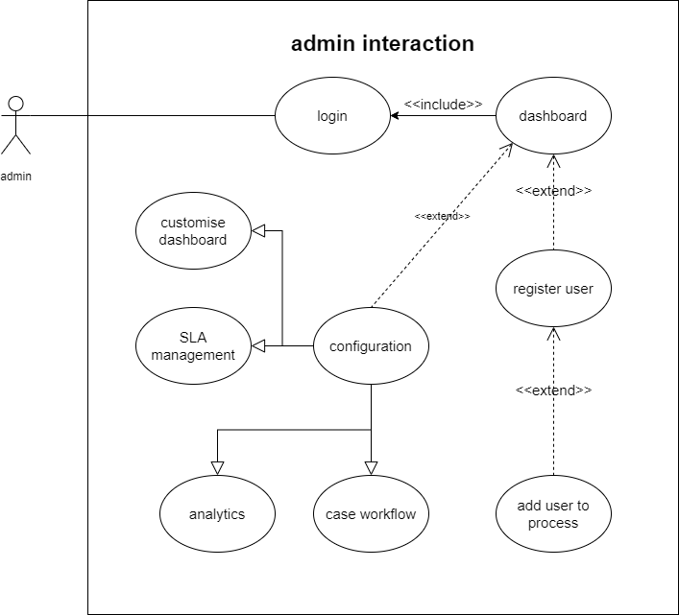

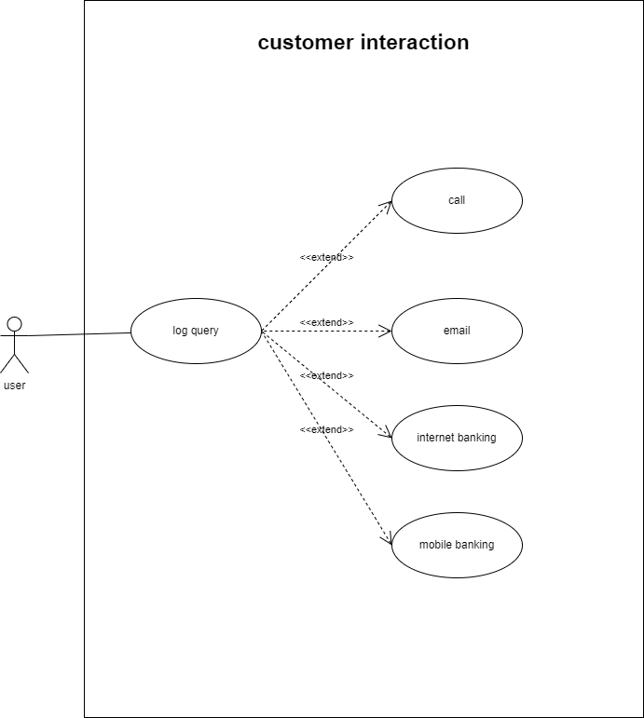
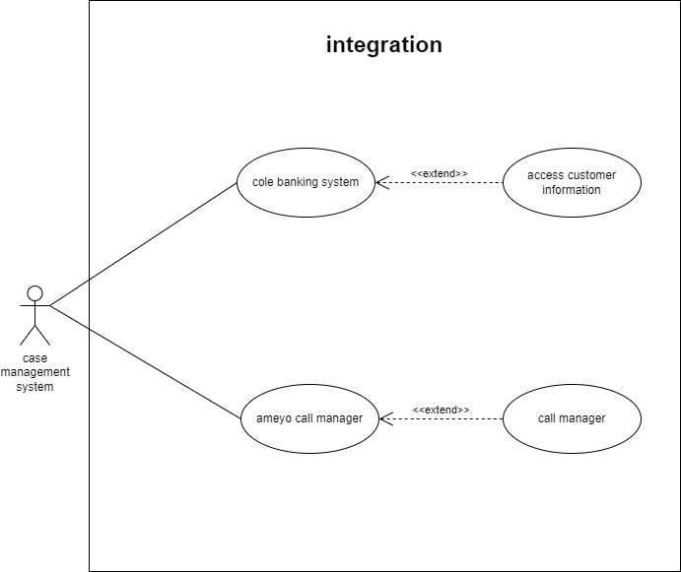

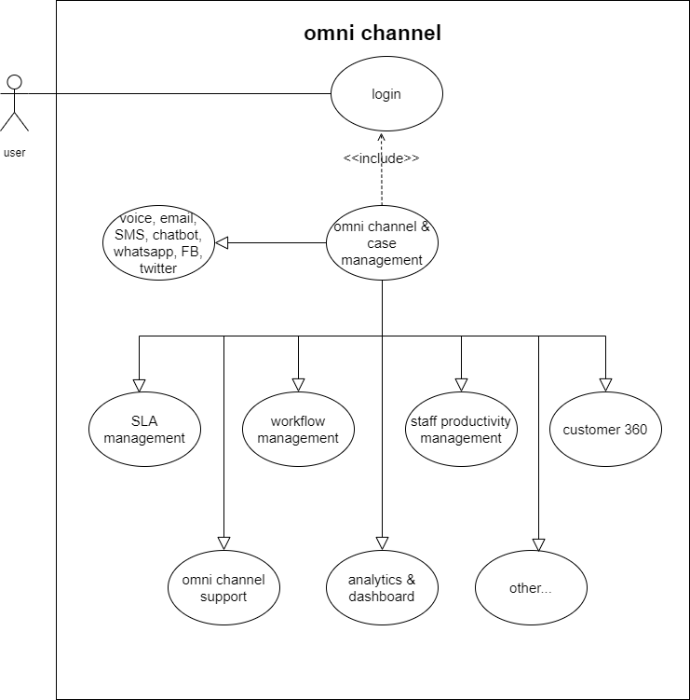

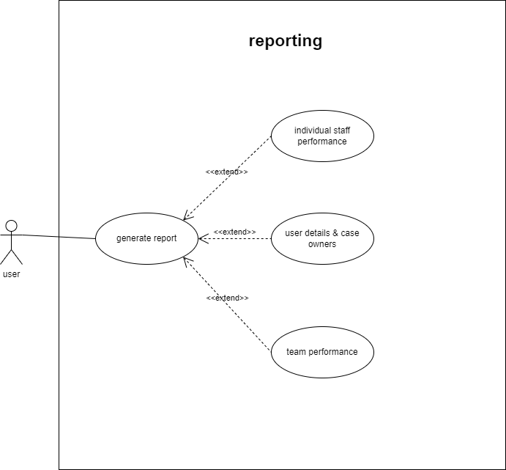

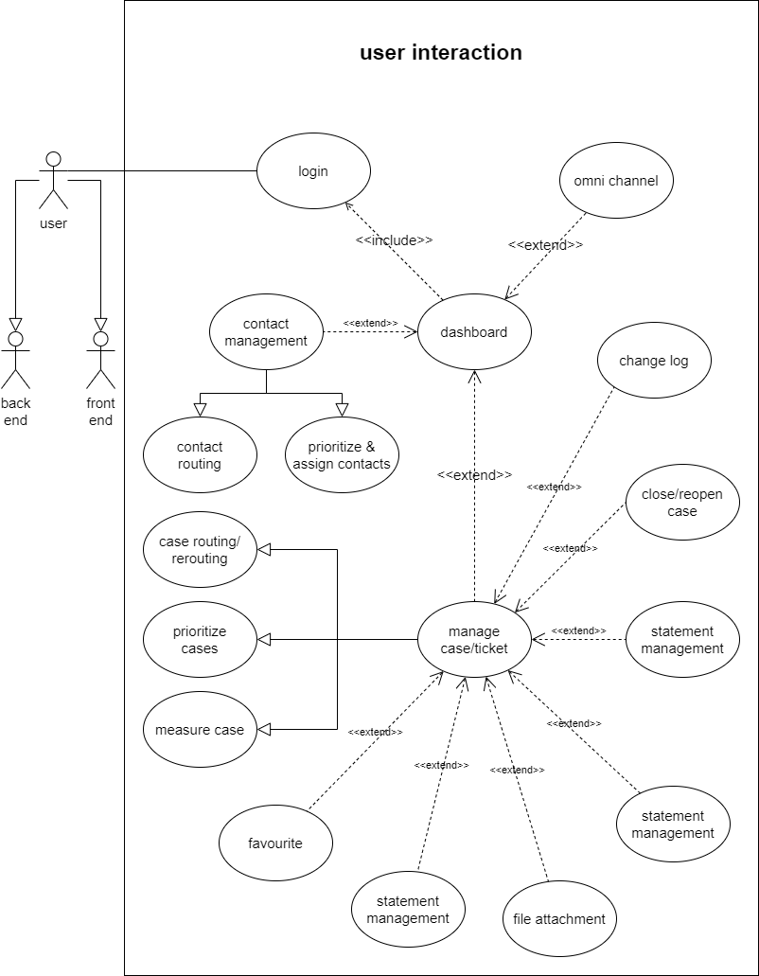

Technical Specifications

Architecture | Servers | Access Requirements | Databases | Supporting Product Configurations | User Access Channels
- 2 tier architecture  - Application tier  - Database tier | Vendor discretion | Web interface.  System to comply with current user access and password policies of Zanaco. | Vendor discretion – MSSQL preferred | No product are required for this implementation | - Web browser  - Email  - WhatsApp  - Facebook  - Twitter

Business Case

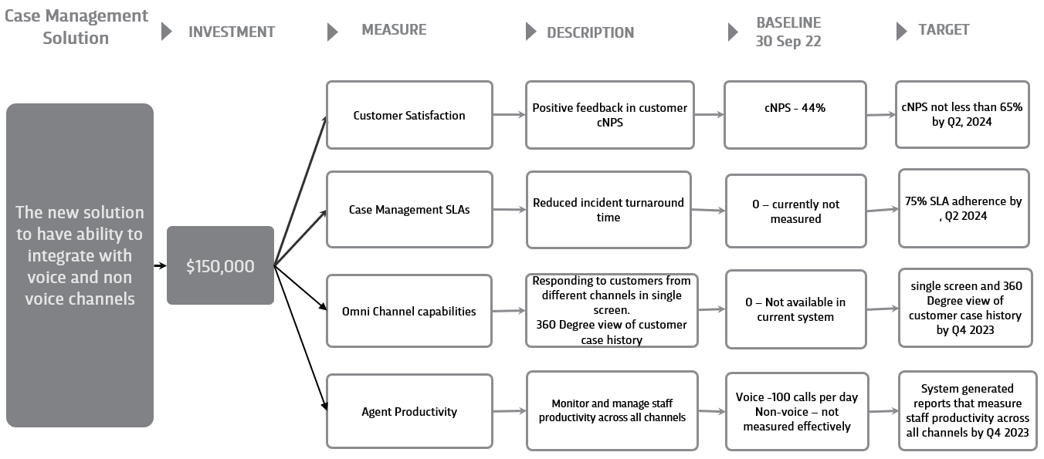

Key Notes

Assumptions | Concerns | Issues
The case management system is a separate system from the Interactive Voice Response system. | - The business would like to have the solution ready by end of Q1 2023 which is a very short time considering that we are at the end of January 2023.  - The requirements for this project have some similarities with the Microsoft CRM Solution. However, the business sighted the examples below as deficiencies in the CRM system.  - The steps involved in case creation is lengthy and complex for users in a busy environment.  - Case management reports lacks key attributes such product and services. We tried workarounds and failed to get through with this piece.  - Additionally, social media integration does supports not include messaging and comments. As such we cannot support social media.

