

P O Box 33611 Tel: 260 211 221355/227989
Lusaka Fax: 260 211 238181

15th February, 2023

ADDENDUM NO.1

RE: ZNCB/RFP/P&F/010/2023 - TENDER FOR THE SUPPLY, DELIVERY AND INSTALLATION OF VARIOUS OFFICE FURNITURE FOR THE ZAMBIA NATIONAL COMMERCIAL BANK

Reference is made to the above captioned request.

Kindly be informed as follows:

NO | QUERY | RESPONSE
1 | Cluster colour (maple etc.) | Red Mahogany
2 | Chair colour (red black) | Black
3 | Kindly provide a floor plan with measurements of both offices on both floors in which the furniture is to be delivered to and assembled in
4 | Please specify which lots of furniture from the required list will be allocated to which floor exactly | 50 workstations spaces, x 4 supervisor workspaces, for 16th Floor The rest of furniture requirement is for 3rd floor space
5 | Kindly share a sample picture of the workstations required with the heightened middle partitioning | 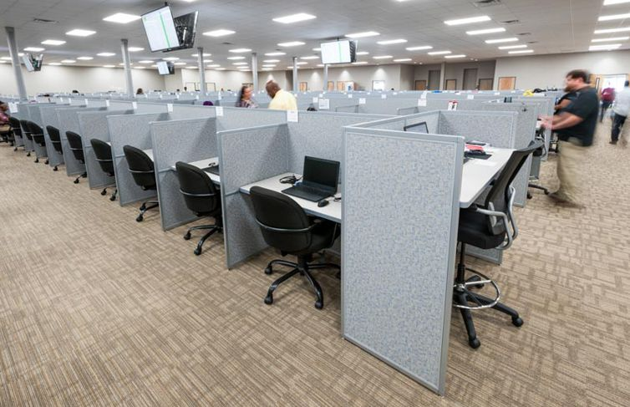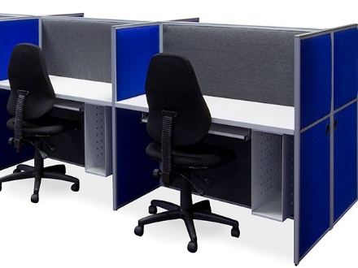
6 | Please confirm that the workstations are required to seat 50 agents | 50 Agents
7 | Kindly confirm that the 4 supervisor workstations are to be connected to that of the 50 agents’ workstations | 4 supervisors connected to that of the 50 workstations  ( Each supervisor workstation connected to a role of call center workstation in T arrangement as illustrated in the picture below)  Supervisor
8 | Please advise on the amended number of seaters required for the conference tables as having physically inspected the designated conference rooms they are too small to accommodate 10-seater conference table | Amended to 8-Seater Conference table.
9 | Kindly confirm on the amended size of the executive office tables to 1.6m in size for the 14 pcs required as having physically inspected the designated rooms they are too big enough to accommodate the said measurements as discussed in the meeting | Amended to 1.6m
10 | Please confirm the material for each of the lots of chairs required i.e. leather or fabric etc. | See attached detail.
11 | Kindly confirm 3rd of March 2023, Friday before 15pm is the final date of closing? | Closing date is 3rd March 2023 at 15:00hrs
12 | We will prefer to have the floor plan and site visit with my shop floor colleagues. These will help us make an offer most suitable to your requirements. Can we plan a site visit during next week? | Site visit to be pre- arranged -
13 | In the RFP, there is an embedded file titled 'General Terms and Conditions' but we are unable to view that. Can we have access to that file? | The general terms and conditions will be in the supply contract which will be shared with the successful bidder for review and to be agreed upon by both parties.
14 | Do you need a Power of Attorney for the person signing the bid? | Yes
15 | Kindly clarify on the 29 Executive customer sliding chairs, what kind of chairs are they? | -Customer sliding should be leather visitor’s chairs -See attached Detail
16 | Page 12 ‘Each item should be priced separately’ – does this mean separate quotations for each item? | You can price different items on one quotation
17 | Page 4 clause 2.6 says ZANACO shall deduct withholding tax. Is it VAT withholding? | Kindly ignore
18 | Are prices to include VAT or not? | VAT and any other taxes to be included to the quotations
19 | please clarify on the number of copies to be submitted in paper format and also in soft copy. | One original and two copies to be submitted
20 | item number 3 executive table 1.2m, please clarify on whether it should have an attached pedestal or side return. Please note that small sized office tables do come with either an attached or mobile pedestal in order to leave room for sitting space. | 1.4m Managers table not be come with return side table’s 14 #
21 | item number 8 low back swivel chairs, please clarify on the material. should it be fabric or leather? | Fabric
22 | 5.lastly please let us know if we will be welcome to attend the tender opening on the closing date. | All representative is free to attend the tender opening
23 | What is the delivery period? | Vendor to indicate the delivery period
24 | Do you have a specific type of color for Works stations/clusters? | Mahogany
26 | Please select the items required for us to quote from the catalogue.  If you require customised furniture then share the pictures and specs of what is required so we can get the factory to quote accordingly.  Note customised furniture will take 3-4 months to arrive from receipt of the LPO. | SCM ???

Please note that all the other details pertaining to the tender remain unchanged.

Regards,

